**Brochure Content**

**Cover Page – Company name, logo and punchline! TheoreX for Schools**

**TheoreX Logo**

**Learn. Create. Execute.**

**Punchline - “Where learning is defined by Creativity and Experience”**

**Why TheoreX**

Our primary objective is to empower students and enhance their engagement with their theory subjects using the latest technologies (Artificial Intelligence, Machine Learning) in E-Learning to make “studying” a more interactive and enjoyable experience! At TheoreX, we don’t just believe in Learning; we believe in Execution, Experience and Results.

We can become a constant Career Guide for the budding talents of your school!

**Why TheoreX is targeting Your School**

Because schools are the first place where students learn how to gain knowledge, how to interact with people, and how to develop into productive members of the society. For the future citizens of our country, schools are the first point of contact with the outside world.

1. Increase engagement with the study material: improve learning outcomes
2. Enhance free thinking and risk-taking attitudes: not encouraged in traditional schools
3. Inculcate independence and self-accountability
4. Become employable in the Digital Workplace: appropriate online behavior, cyber safety, avoid plagiarism, teamwork, self-discipline, entrepreneurship, leverage globalization

**E-Learning Infographic by Docebo:**

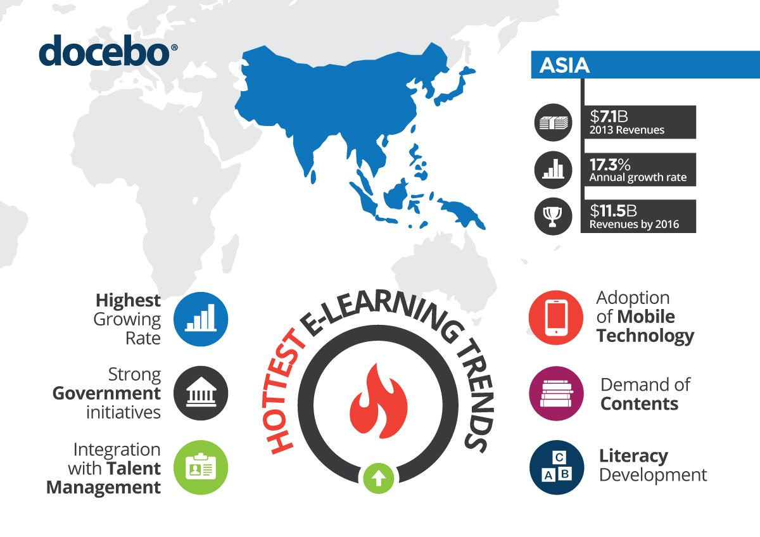

By engaging with students’ right from their childhood we can certainly disrupt the established Education Market in India, the fastest growing E-learning market in the world! These are the statistics at present; let’s change them for the better.

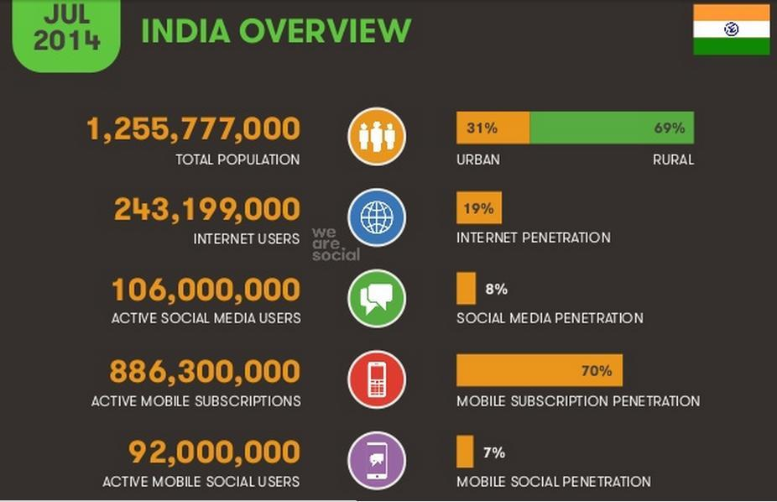

**Our Services for Your School:**

Right now TheoreX is focusing on the Computer Sciences and its ancillaries. Services on offer to schools right now include:

1. Extra Classes (max 2) every week on the latest Digital Technologies and emerging Programming Languages by the top instructors in Kolkata who are already working with Major Corporate Entities or have several years of experience in the industry.
2. Crash Course Workshops on the latest subjects in Computer Science & Technology

**Detailed Description of Services:**

**For Class IX**

**Extra Class**

Subject Name - Programming Paradigm and Knowledge on ANSI C

Why C? - C is a powerful general-purpose programming language. It is fast, portable and available in all platforms. C is the Godfather of every programming language exists in this earth!

Topics in C –

**INTRODUCTION**

Keywords & Identifier, Variables & Constants, C Data Types, C Input/Output, C Operators, Basic Examples

**FLOW CONTROL**

if...else Statement, C for Loop, C while Loop, break and continue, switch Statement, Decision Examples

**FUNCTIONS**

Functions Introduction, User-defined Function, Function Types, Recursion in C, Variable Scope, Function Examples

**ARRAYS**

C Arrays Introduction, Multidimensional Array, Arrays & Functions, Strings in C, String Functions, Array Examples

**C POINTERS**

C Pointers, Pointers & Arrays, Pointers & Functions, Memory Management, Pointer Examples

**STRUCTURE & FILE**

C Structure, Structure & Pointers, Structure & Functions, C Unions, Structure Examples, Files Handling

**ADDITIONAL RESOURCES**

C Examples, C Library Function

**Top Perks:**

1. Global Certifications and more rewards

2. Learning the basic of Programming

3. Learn from top professional instructors

4. Working on real life projects

**Price – 300/- per student per month**

**For Class X**

**Extra Class**

Subject Name – Dive deep into Java Programming Language

Why Java? – Java is a popular general-purpose programming language and computing platform. It is fast, reliable, and secure. According to Oracle, the company that owns Java, Java runs on 3 billion devices worldwide. Considering the number of Java developers, devices running Java, and companies adapting it, it's safe to say that Java will be around for many years to come.

Topics in Java –

**Learn the Basics**

Hello, World, Variables and Types, Conditionals, Arrays, Loops, Functions, Objects, Compiling and Running with Arguments

**Advanced Topics**

Inheritance, Try and Catch, Abstract Classes, Interfaces, Using Generics, Collections, Wrappers and Autoboxing, Exceptions, Generic Types, IO Streams

**Top Perks:**

1. Global Certifications and more rewards

2. Learning the basic of Programming

3. Learn from top professional instructors

4. Working on real life projects

**Price – 300/- per student per month**

**For Class XI**

**Extra Class**

Subject Name – Deep dive into C++ and its Programming

Why C++? – Recommended by almost all universities for beginners, C++ takes a massive market in development of today’s modern systems. C++ ranks 4th in popularity according to 2016 IEEE spectrum Top Programming Language ranking. Learning C++ is a wise investment for all programmers.

Topics in C++ -

**FLOW CONTROL**

if...else Statement, for Loop, do...while Loop, break & continue, switch Statement, goto Statement

**FUNCTIONS**

C++ Functions, Function Types, Function Overloading, Default Argument, Storage Class, C++, Recursion

**STRUCTURES**

Structure, Structure and Function, Pointers to Structure, Enumeration

**ARRAYS & STRING**

C++ Arrays, Multidimensional Arrays, Function and Array, C++ String

**OBJECT & CLASS**

Objects and Class, C++ Constructors, Objects & Function, Operator Overloading

**INHERITANCE**

C++ Inheritance, Function Overriding, Multilevel Inheritance, Friend Function, Virtual Function, Templates

**POINTERS**

C++ Pointer, Pointers and Arrays Pointers and Functions Memory Management

**Crash Course:**

Intensive short duration courses on Web Development, Cloud Computing, Ethical Hacking, Artificial Intelligence etc.

**Top Perks:**

1. Global Certifications and more rewards

2. Learning the basic of Programming

3. Learn from top professional instructors

4. Working on real life projects

5. Learning about latest technologies from Crash Courses

**Price – 400/- per student per month**

**For Class XII**

**Extra Class**

Subject Name – Python and its Necessity

Why Python? – Python is a powerful high-level, object-oriented programming language created by Guido van Rossum. It has simple easy-to-use syntax, making it the perfect language for someone trying to learn computer programming for the first time.

Topics in Python –

**INTRODUCTION**

Keywords & Identifier, Statements & Comments, Python Datatypes, Python I/O and Import, Python Operators, Operator Precedence

**FLOW CONTROL**

Python if...else, Python for Loop, while Loop, break and continue, Pass Statement, Looping Technique

**FUNCTIONS**

Python Function, Function Argument, Python Recursion, Anonymous Function, Python Modules, Python Package

**NATIVE DATATYPES**

Python Numbers, Python List, Python Tuple, Python String, Python Set, Python Dictionary

**FILE HANDLING**

File Operation, Python Directory, Python Exception, Exception Handling, User-defined Exception

**OBJECT & CLASS**

Python Namespace, Python Class, Python Inheritance, Multiple Inheritance, Operator Overloading

**ADDITIONAL TUTORIALS**

Iterators, Generators, Closures, Decorators, @property

**Crash Course:**

Intensive short duration courses on Web Development, Cloud Computing, Ethical Hacking, Artificial Intelligence etc.

**Top Perks:**

1. Global Certifications and more rewards

2. Learning the basic of Programming

3. Learn from top professional instructors

4. Working on real life projects

5. Learning about latest technologies from Crash Courses

**Price – 400/- per student per month**

**Our Top Instructors:**

Somnath Roychoudhury – Somnath has a Masters in Computer Application from ICFAI University and has 10+ years of teaching experience and 12+ years of Working Experience with RS Software. His area of expertise is in several programming languages.

Specialty – C, Java, Python and any programming language.



Vishal Dave – Vishal has 8 Years of proven track record in establishing and growing completely new products into brands at rural and urban level, “Big box” retail and IT Security products and services. He is also an expert in Ethical Hacking and a renowned name in Cloud Technologies.

Specialty – Hacking, Networking, Cloud Computing, Python etc.



Joydeep Sarkar – Joydeep is a Certified Ethical Hacker and a Computer Hacking Forensic Investigator certified by the EC Council and has more than 3 years of experience with Cyber Forensic Investigation Department with the Siliguri Police. He is also an expert on the Python Programming Language.

Specialty – Hacking, IOT, Cloud Computing, Python etc.



And many more…

**Future Scope for Your School & Students:**

The most important thing that matters to us is the bright future of the students and their school. TheoreX is on its way to implementing a lot of exciting products using latest technologies which the E-learning industry is yet to discover! TheoreX services will be beneficial to school students as a constant guide that will show them the right path throughout their careers! TheoreX product will also help teachers track students’ progress and guiding them in designing personalized content for each student.

**Benefits of Your School:**

* Brand value of your school will be one step ahead of others
* Your school students will have a bright future ahead
* The value of your school students as well as you school will be increased along with us
* The result of your students will be high!

**Benefits of Your Student:**

* Global certification from different IT giants like Microsoft, Google and many more
* Participating in different competition around the world and get top achievements
* Participating in Google Summer Of Code and getting chance to work with the IT Giants
* Participating in Indian computing Olympiad and get top achievements

**Team & Contact Details (with Photo):**

**Executive Team -**

Ayan Choudhury

Chief Executive Officer, TheoreX

Mozilla Representative, India

Open Source Evangelist



Gaurab Patra

Chief Technology Officer, TheoreX

Mozilla Representative, India

Open Source Evangelist



**Contact Persons -**

Sayantan Saha

+91-9732372287

sayantan@theorex.io



Sayan Samaddar

+91-7278926805

sayan@theorex.io



**About TheoreX Footer**:

TheoreX Edutech LLP

www.theorex.io

info@theorex.io

+91-9874624549, +91-9874975638

71, Sonali Park, Garia, Kolkata - 84, India

**Use these logos in footer section of last page**

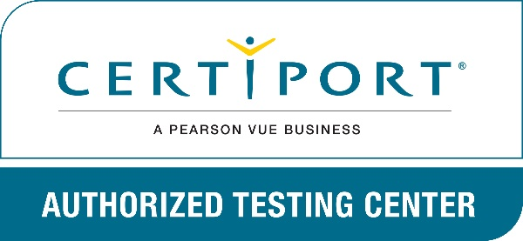

**Back Cover Quotation:**